Department of Computer Engineering
TE Computer-A (2020-21 Sem I)
Computer Networks Practical
Assignment A7 [Max Marks: 10]

OUTPUT
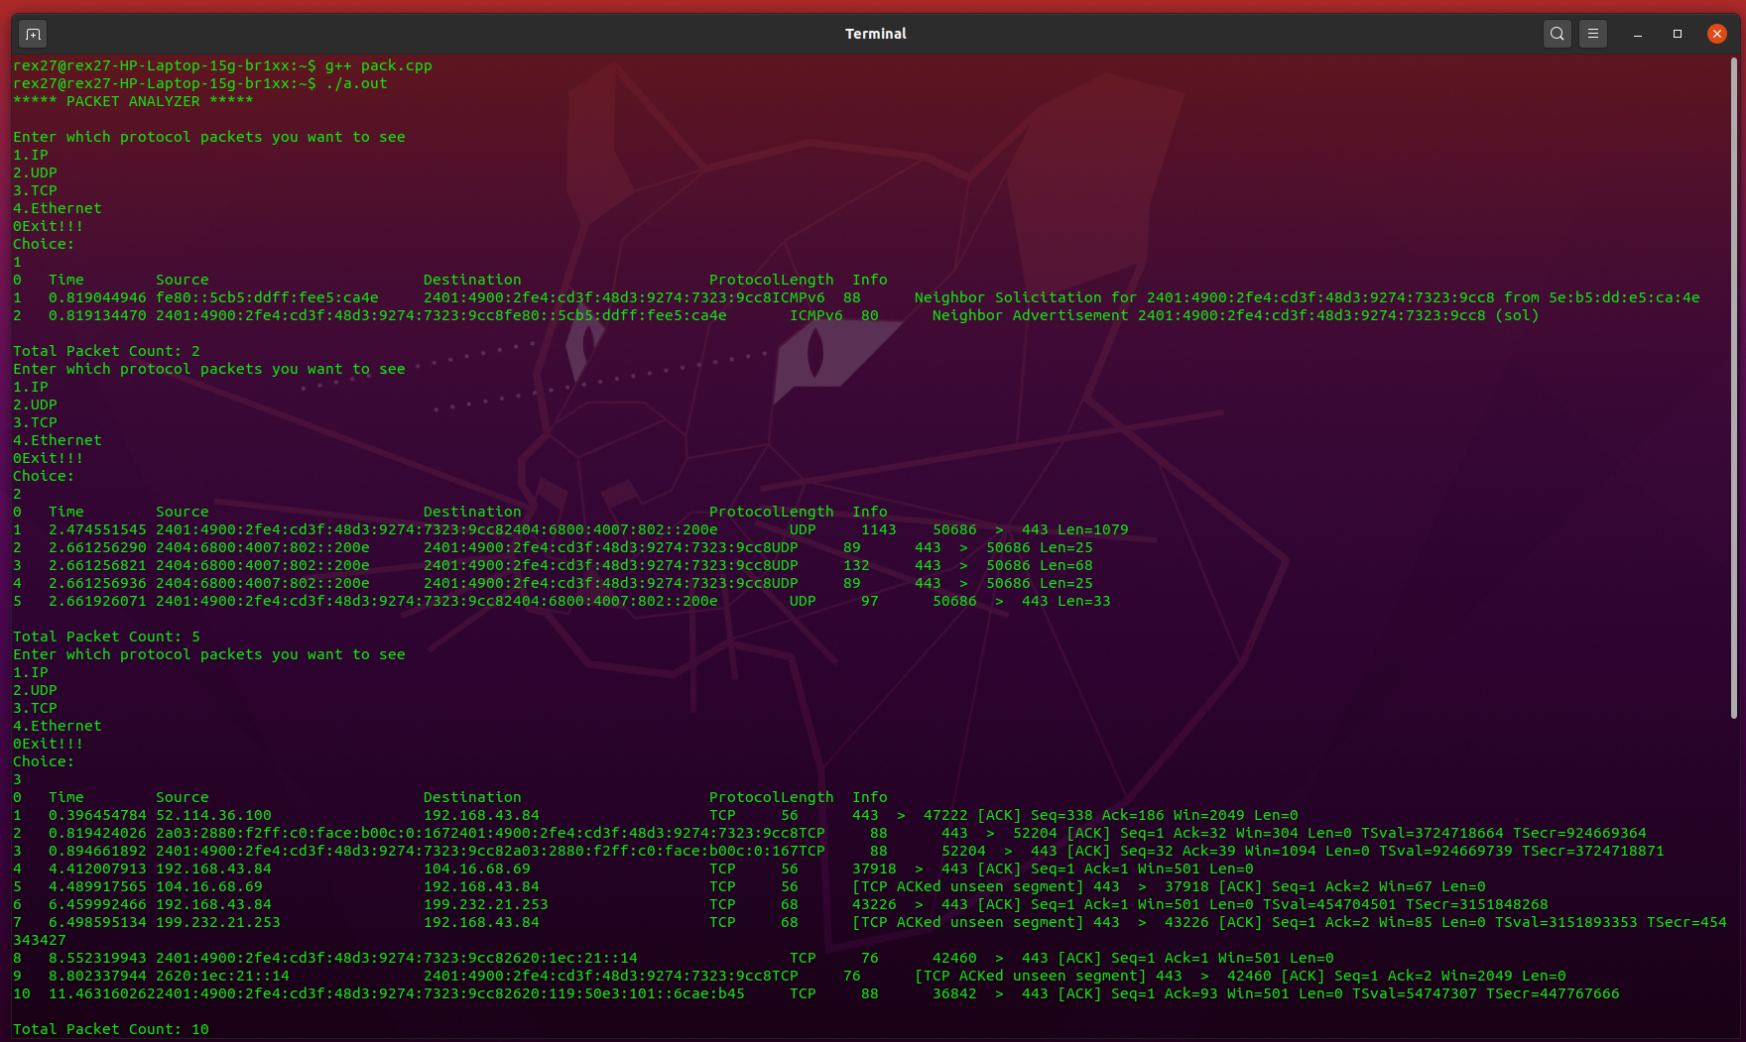

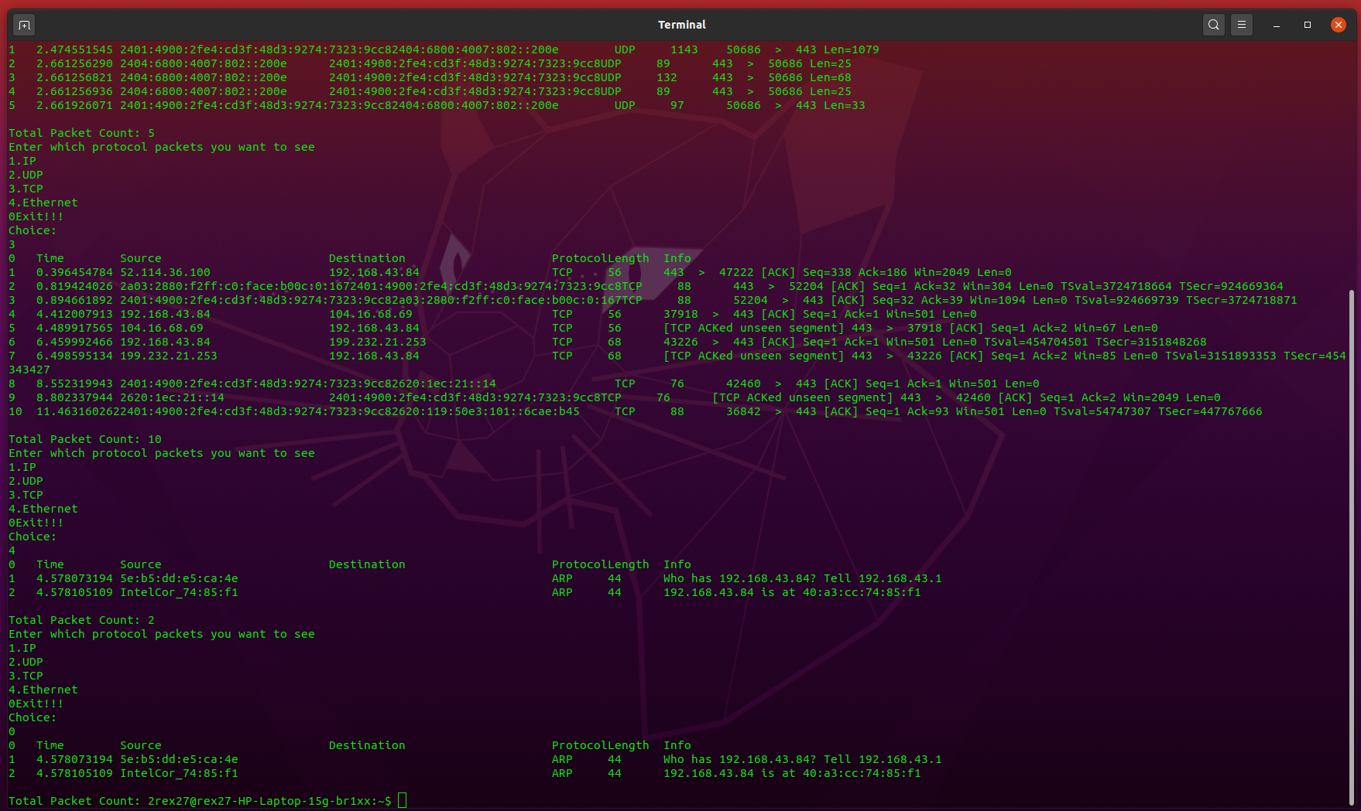
Firstly wireshark file is exported as csv file and then used in this program.

